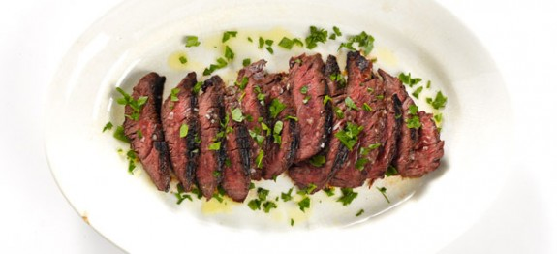

**Garlic Steak**

**Ingredients:**

* 1 1 1/2-lb. hanger, skirt, or flatiron steak (about 14 oz. trimmed)
* Kosher salt and freshly ground black pepper
* 1 1/2 tablespoons unsalted butter
* 1/2 garlic clove, minced
* Coarse sea salt
* Chopped flat-leaf parsley

**Method:**

1. Build a medium-hot fire in a charcoal grill, or heat a gas grill to high. Season steak generously with kosher salt and pepper. Melt butter in a small skillet over medium heat until foamy. Remove skillet from heat. To clarify the butter, use a spoon to skim foam floating on surface of butter; discard foam. Add garlic to clarified butter and let it infuse while the steak is cooking and resting.
2. Grill steak, turning once, until cooked to desired doneness, about 5 minutes per side for medium-rare. Transfer steak to a cutting board and let it rest for 10 minutes. Thinly slice steak against the grain. Divide steak between plates and spoon garlic butter over top. Season with sea salt and garnish with parsley.

[source:](http://www.bonappetit.com/recipes/2012/07/st-anselms-garlic-steak)